|  |  |
| --- | --- |
| **Name** | Muhammad Arslan Raza |
| **Section** | A |
| **Roll No.** | 2020-EE-403 |

**Thermodynamics Lab 1**

**Layout of Thermodynamics Lab**

**What is layout?**

Layout is defined as a process to locate and marks a work piece in order to give guidance to the machinist or the visitor. **Or** The process of setting out material on an area.

**Purpose of layout:**

Layout act as a visual reference to the machinist. It provides **proper direction** for manufacturing operation. It guides machinist to his desired place or point.

|  |  |  |  |  |  |
| --- | --- | --- | --- | --- | --- |
|  | | | | Thermodynamics Lab |  |
| Sr No. | | | | **Apparatus Name** | **Model No.** |
| 1 | | | **1.1** | Rankin Cycle System Turbine Hydrolic Bench | S220 |
| 2 | | | **2.1** | Nozzle Pressure Distribution | F 300B |
|  | | | 2.2 | Nozzle Pro | F 300A |
|  | | | | Compressionable Flow Range | F300 |
| 3 | | **3.1** | | Absorption Refrigeration | 816/01295 |
|  | | **3.2** | | Heat Transfer Service Unit | H112 |
|  | | **3.3** | | Boiling Heat Transfer Module |  |
| 4 | | 4.1 | | Thermal Radiation Equipment | TE6C/EV |
|  | | 4.2 | | Heat Transfer Service Unit | TE6/EV |
|  | | 5.1 | | Heat Exchanger Service Module | TD360 |
|  | **5.2** | | | Heat Transfer Equipment Base Unit | TD102 |
| 6 | **6.1** | | | Heat Pump Trainer | BPC/EV |
| 7 | **7.1** | | | Cross Flow Heat Exchanger | TE93 |
| 8 | **8.1** | | | Four Stroke Singal Cyclinder Diesal Engine Demonstration Unit | IPC-9200-DE |
|  | **8.2** | | | Two Stroke Petrol Engine Demonstration Unit | ART-NR-4042 |
| 9 | **9.1** | | | Cooling Tower Trainer | RAD-CTS-3 |
| 10 | **10.1** | | | Labortary Air Conditioning Trainer | IPC-512-RAC |
| 11 | **11.1** | | | Mechanical Heat Pump Trainer | IPC-2002-RH |
| 12 | **12.1** | | | Commercial Refrigeration Trainer | IPC-2007-1 |
| 13 | **13.1** | | | Vortex Tube Refrigerator | R434/07043 |
| 14 | **14.1** | | | Thermo Electric Heat Pump | R534 |

**1.1 Two Stroke Petrol Engine:**

A **two-stroke** (or **two-cycle**) **engine** is a type of internal combustion engine which completes a power cycle with two strokes (up and down movements) of the piston during only one crankshaft revolution. In a two-stroke engine, the end of the combustion stroke and the beginning of the compression stroke happen simultaneously, with the intake and exhaust functions occurring at the same time.

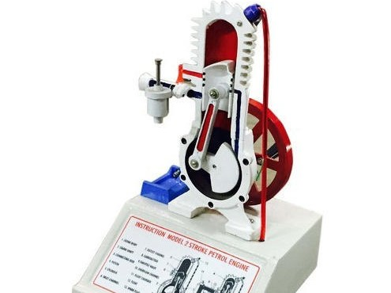

Figure no. 1.1(a): Model of Two Stroke Petrol Engine.

**1.2 Four Stroke Single Cylinder Diesel Engine:**

A **four**-**stroke engine** (also known as **four**-**cycle**) is an internal combustion **engine** in which the piston completes **four** separate **strokes** which constitute a single thermodynamic **cycle**. A **stroke** refers to the full travel of the piston along the cylinder, in either direction.

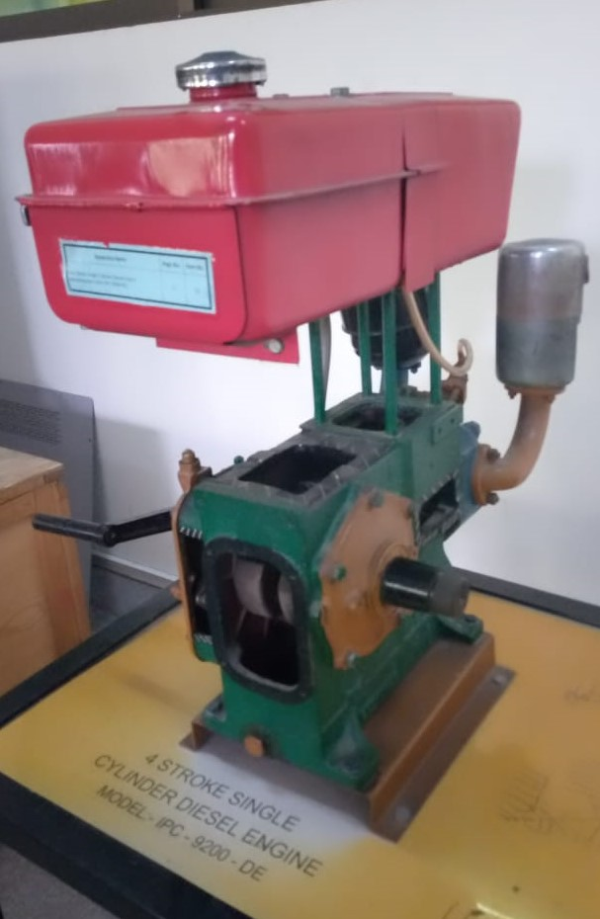

Figure No. 1.1(b): Model of Four Stroke Single Cylinder Diesel Engine.

**2 Rankine Cycle Steam Turbine:**

The **Rankine cycle** is a model used to predict the performance of steam turbine systems. It was also used to study the performance of reciprocating steam engines. The Rankine cycle is an idealized thermodynamics cycle of a heat engine that converts heat into mechanical work while undergoing phase change. It is an idealized cycle in which friction losses in each of the four components are neglected. The heat is supplied externally to a closed loop, which usually uses water as the working fluid.

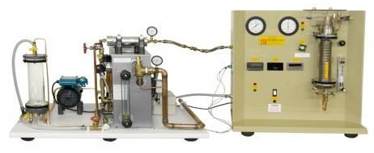

Figure No. 1.2: Model of Rankine Cycle Steam Turbines.

**3.0 Compressible Flow Range:**

**Compressible flow** (or **gas dynamics**) is the branch of fluid mechanics that deals with flows having significant changes in fluid density. While all flows are compressible, flows are usually treated as being incompressible when the Mach number (the ratio of the speed of the flow to the speed of sound) is less than 0.3 (since the density change due to velocity is about 5% in that case). The study of compressible flow is relevant to high-speed aircraft, jet engines, rocket motors, high-speed entry into a planetary atmosphere, gas pipelines, commercial applications such as abrasive blasting, and many other fields.

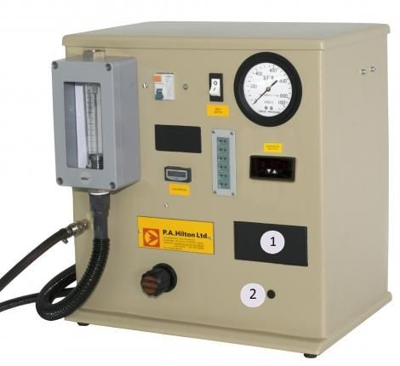

Figure no. 1.3(a): Model of Compressible Flow Range.

**3.1 Nozzle Pressure Distribution:**

The Nozzle Pressure Distribution Unit, “TPT”, allows to investigate the pressure distribution and the mass flow rate in nozzles (convergent divergent and convergent nozzles). The unit includes three types of nozzles: Convergent type (conical) nozzle, with 6 pressure tapings. Convergent-divergent nozzle, with 5 pressure tapings. Convergent-divergent nozzle, with 8 pressure tapings. The nozzles are made of brass and have been mechanized accurately. Several pressure tapping are available, being each one connected to its own manometer.

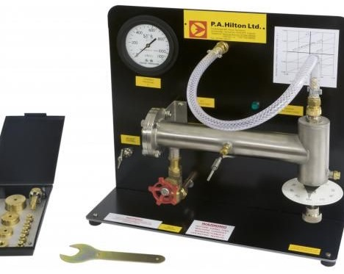

Figure no. 1.3(b): Model of Nozzle Pressure Distribution.

**3.2 Nozzle Pro:**

Nozzle PRO is a unique and easy-to-use FEA tool for vessel and piping engineers.  It is specifically designed to analyze individual nozzles (straight, hillside, pad-reinforced), saddles, lugs and pipe shoes. Reinforcing pads for lugs and wear plates for shoes and saddles can be integral and non-integral.  You can include beam elements to pipe up to the nozzle in order to include the correct attached pipe stiffness and thus applying the correct loads in your analysis.

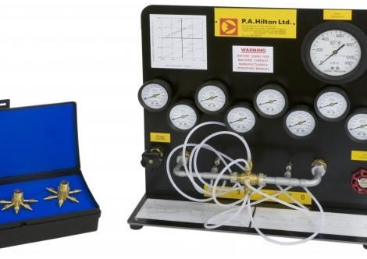

Figure no. 1.3(c): Model of Nozzle Pro.

**4 Radiation Heat Transfer:**

Both conduction and convection require matter to transfer heat. Radiation is a method of heat transfer that does not rely upon any contact between the heat source and the heated object. For example, we feel heat from the sun even though we are not touching it. Heat can be transmitted though empty space by thermal radiation. Thermal radiation (often called [infrared radiation](http://coolcosmos.ipac.caltech.edu/cosmic_classroom/ir_tutorial/what_is_ir.html)) is a type [electromagnetic radiation](http://imagers.gsfc.nasa.gov/ems/waves.html) (or light). Radiation is a form of energy transport consisting of electromagnetic waves traveling at the speed of light. No mass is exchanged and no medium is required.

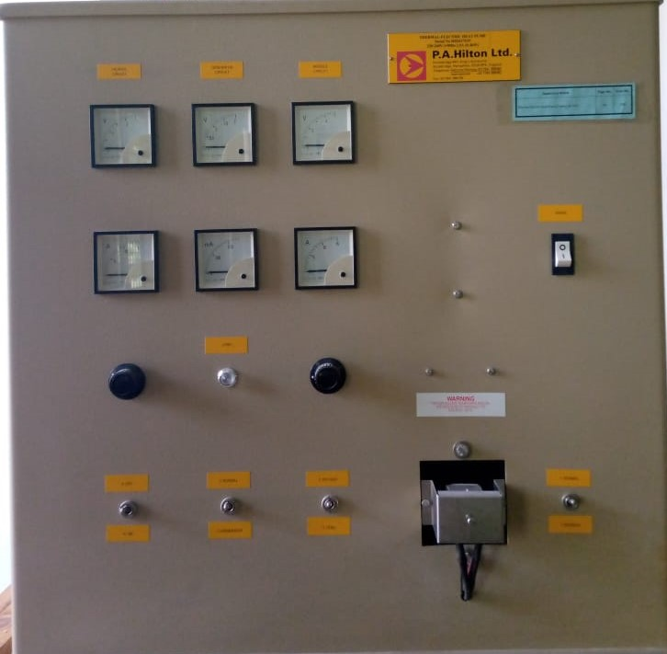

Figure no. 1.4: Model of Radiation Heat Transfer.

**5 Boiling Heat Transfer Module:**

A bench top accessory designed to allow students to experimentally investigate convective, nucleate and film boiling. The unit consists of a high strength clear glass cylinder with

instrumented electric heater element immersed in a volatile solvent that boils at low pressure.

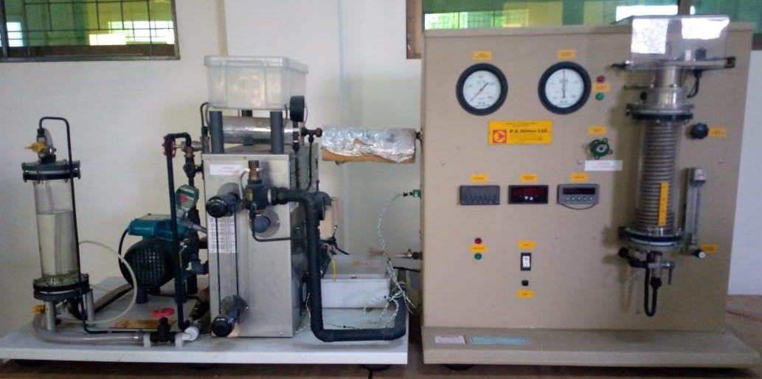

Figure no. 1.5: Model of Boiling Heat Transfer Module.

**6 Flow Boiling Demonstration Unit:**

The **Flow Boiling Demonstration Unit** is a floor-mounted unit designed to provide a visual demonstration of the flow boiling processes that can occur inside the vapor generating tubes of practical plant such as refrigeration, steam, chemical and food processing systems**.**

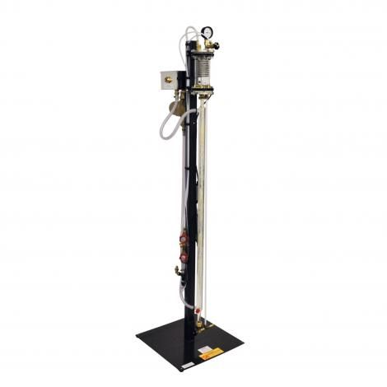

Figure no. 1.6: Flow Boiling Demonstration Unit.

**7.1 Concentric Tube Heat Exchanger:**

The concentric tube heat exchanger was designed in order to study the process of heat transfer between two fluids through a solid partition. It was designed for a counter-flow arrangement and the logarithmic mean temperature difference (LMTD) method of analysis was adopted. Water was used as fluid for the experiment.

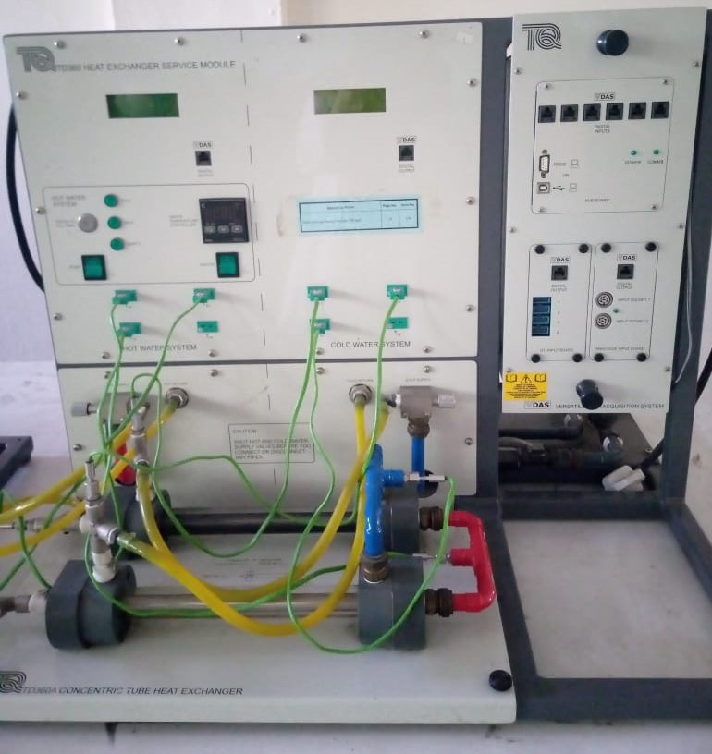

Figure no. 1.7(a): Model of Concentric Tube Heat Exchanger.

**7.2 Linear Heat Transfer Conduction Experiment:**

To Measure the Temperature Distribution For Steady State **Conduction** Of Energy Through A Uniform Plane Wall And Demonstrate The Effect Of A Change İn **Heat** Flow. This **experiment** aims to determine the temperature gradient during **linear heat transfer** by **conduction** along the wall.

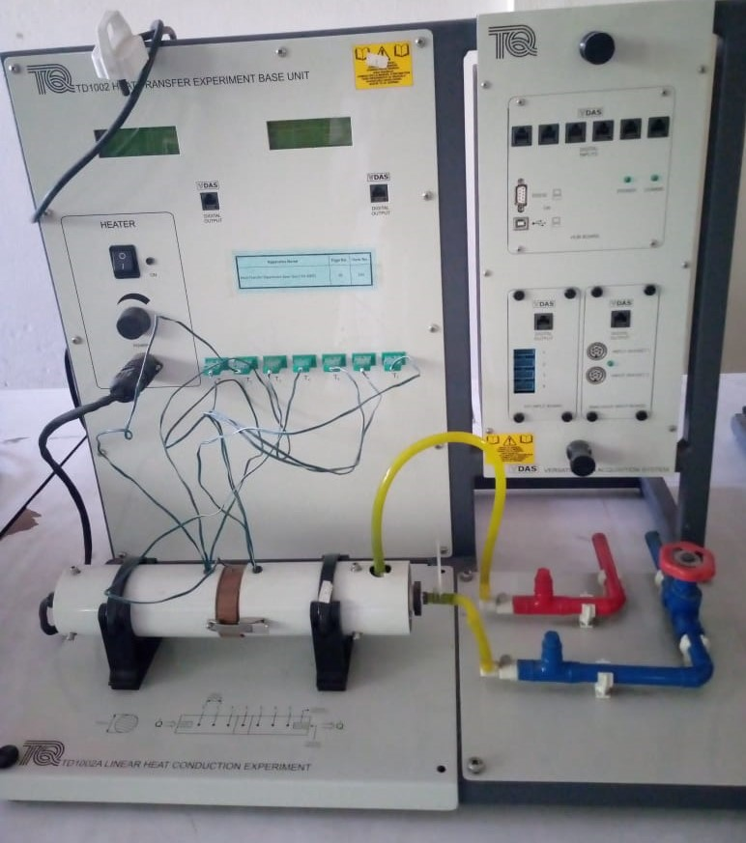

Figure no. 1.7(b): Heat Transfer Unit.

**8.1 Absorption Refrigeration:**

An **absorption refrigerator** is a **refrigerator** that uses a heat source (e.g., solar energy, a fossil-fueled flame, waste heat from factories, or district heating **systems**) to provide the energy needed to drive the cooling process. The principle can also be used to air-condition buildings using the waste heat from a gas turbine or water heater.

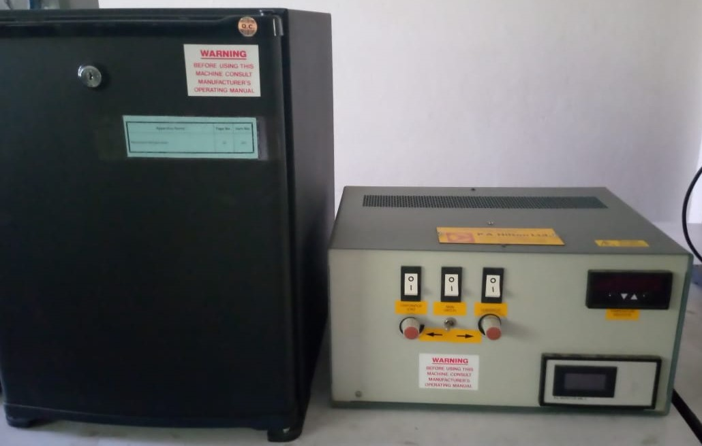

Figure no. 1.8(a): Model of Adsorption Refrigeration.

**8.2 Heat Pump Trainer:**

When it's cold outside a **heat pump** extracts this outside **heat** and transfers it inside. When it's warm outside, it reverses directions and acts like an air conditioner, removing **heat** from your home. One advantage of a **heat pump** is that it moves **heat** instead of generating **heat**, giving you more energy efficiency.

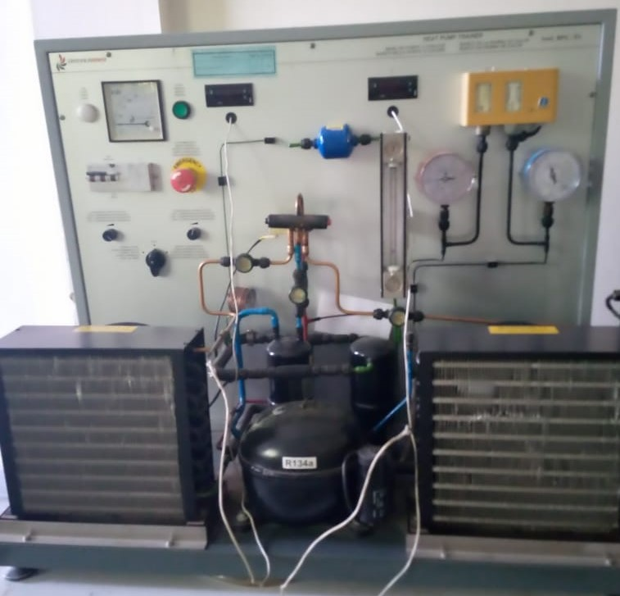

Figure no. 1.8: Model of Heat Pump.

**9 Thermo Electric Heat Pump Trainer:**

A **heat pump** is a device that transfers heat energy from a source of heat to what is called a thermal reservoir. Heat pumps move thermal energy in the opposite direction of spontaneous heat transfer, by absorbing heat from a cold space and releasing it to a warmer one. A heat pump uses external power to accomplish the work of transferring energy from the heat source to the heat sink. The most common design of a heat pump involves four main components – a condenser an expansion valve, an evaporator and a compressor. The heat transfer medium circulated through these components is called refrigerant.

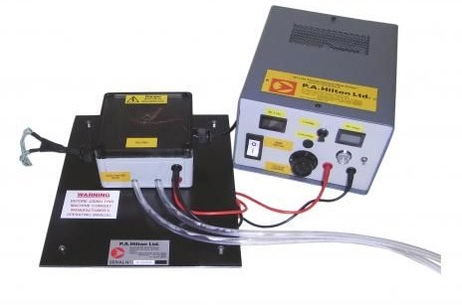

Figure no. 1.9: Model of Thermo Electric Heat Pump.

**10 Vortex Tube Refrigerator:**

The **vortex tube**, also known as the **Ranque-Hilsch vortex tube**, is a mechanical device that separates a compressed gas into hot and cold streams. The gas emerging from the "hot" end can reach temperatures of 200 [°C](https://en.wikipedia.org/wiki/Celsius) (392 [°F](https://en.wikipedia.org/wiki/Fahrenheit)), and the gas emerging from the "cold end" can reach −50 °C (−58 °F). It has no moving parts.

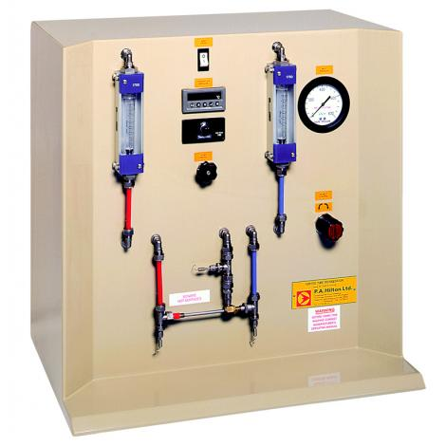

Figure no. 1.10: Model of Vortex Tube Refrigerator.

**11 Commercial Refrigeration Trainer:**

This commercial refrigeration trainer is an advanced unit used to train students in commercial refrigeration and air conditioning systems.

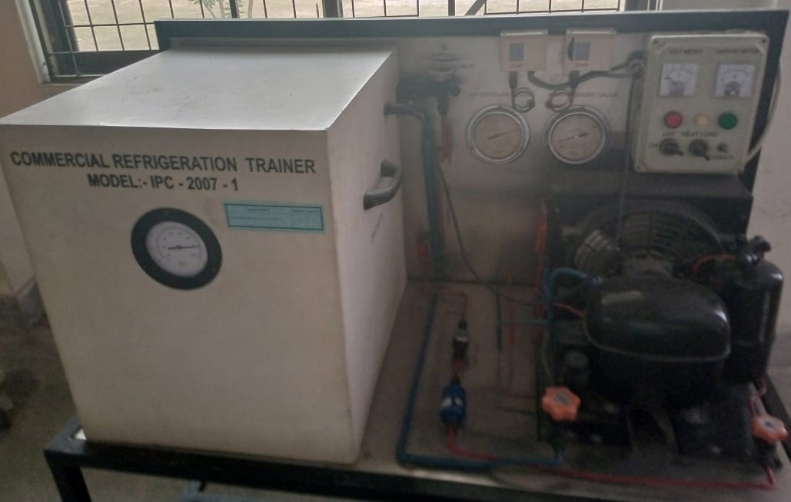

Figure no. 1.11: Model of Commercial Refrigerator.

**12 Mechanical Heat Pump Trainer:**

The mechanical heat pump is the most prevailing heat pump to be applied commercially. Its principle of operation: Inside a mechanical heat pump the pressure of a refrigerant is increased with the use of a compressor. Due to this increase in pressure, the condensation temperature rises. Most installations have an electric motor to drive the compressor. Two types of mechanical heat pumps are available: a system that with direct expansion of the refrigerant at the inlet of the evaporator (dx system) and a so called 'pump system' heat pump where liquid refrigerant is pumped to the evaporators. Both types are described in more detail below.

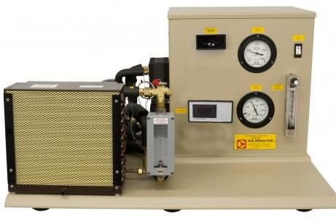

Figure no. 1.12: Model of Mechanical Heat Pump Trainer.

**13 Laboratory Air Conditioning Trainer:**

Air conditioning systems are vital in ensuring the comfort of people at home and in the workplace, and refrigeration systems are essential to the storage and preservation of our food resources. We are especially finding a massive acceptance of these systems in developing nations where they have not been widely used before. This increases the importance of having qualified technicians who can install, service and repair this equipment.

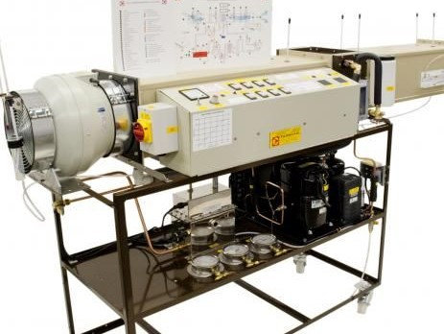

Figure no. 1.13: Model of Laboratory Air Conditioner

**14 Cooling Tower Trainer:**

Cooling towers are used to remove heat from a building. Cooling a stream of water to a lower temperature using evaporation does this. Large cooling towers are usually used in industries like power plants, petroleum refineries and various manufacturing facilities. They vary in size from large hyperboloid structures to smaller ones on the rooftops of shopping centers, hospitals or universities. However, the most common application of a cooling tower is inside an [HVAC system](https://blog.senseware.co/the-complete-guide-to-hvac-performance-and-sustainability-trends-happening-now) (heating, ventilating, and air conditioning) for cooling buildings.

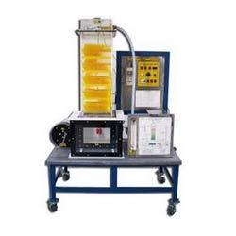

Figure no. 1.14: Model of Cooling Tower Trainer.